.

Lab Task - 1
Only for course Teacher
 |  | Needs Improvement | Developing | Sufficient | Above Average | Total Mark
Allocate mark & Percentage |  | 25% | 50% | 75% | 100%
Clarity
Content Quality
Spelling & Grammar
Organization and Formatting
Total obtained mark
Comments

Semester: Fall 2026
Student Name: Shahriar Salman
Student ID:26010168
Batch: 46 Section: B
Course Code: CSE 124 Course Name: Object Oriented Programming
Course Teacher Name:Debabrata Mallick
Designation: Lecturer
Submission Date: 30/ 07/ 2026
- Write a java program to print “Hello” on the screen and your name on a separate line.
Hello
Shahriar Salman

Solution:
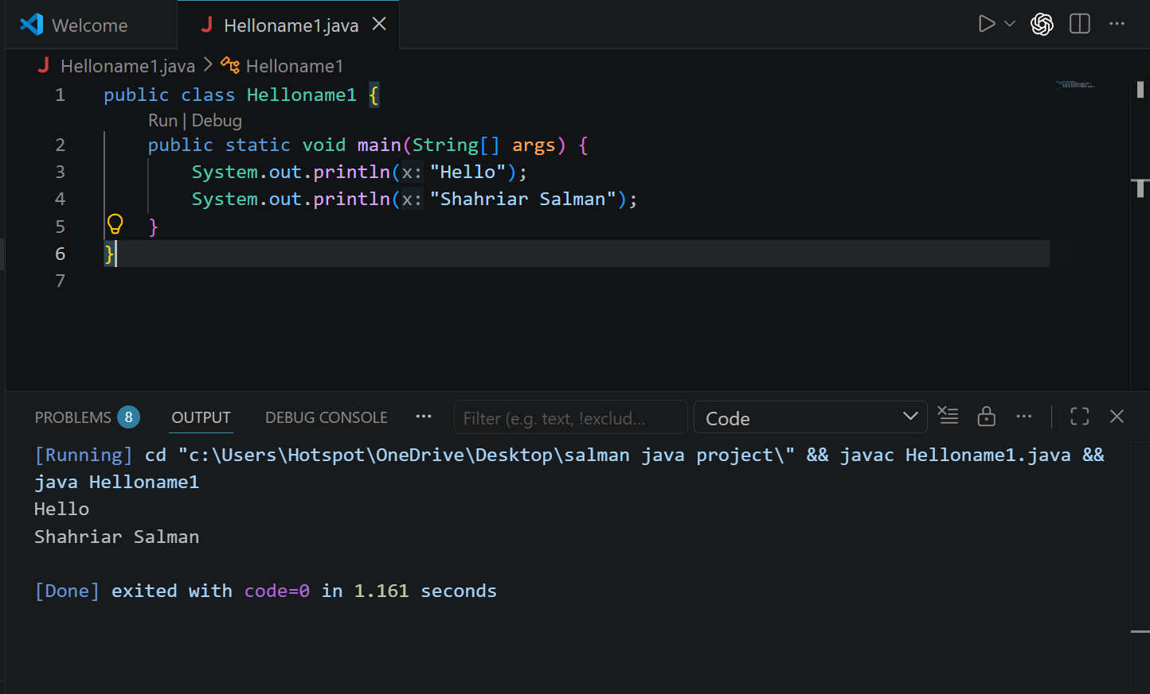

Explanation : Learned how to define or declare java class and main function of java and application output print for any text with System.out.println()

2. Write a java program to sum two numbers.
Given value : 74
36 , 74 +36 = 110
Solution:
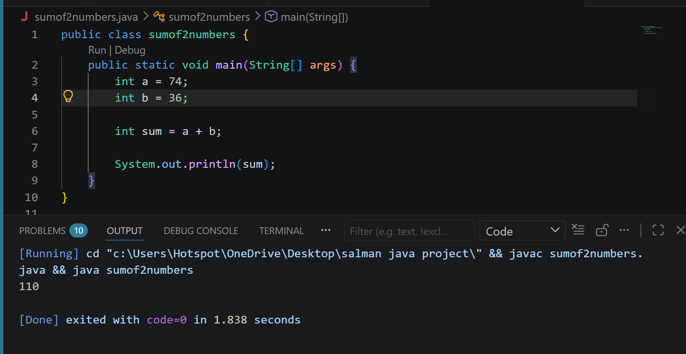

Explanation: Got the idea of adding two numbers and calculating the sum of numbers with integer variables declaring them a = 74 and b = 36 and total of sum = 110

3.Write a java program for division of two numbers.
Give value:
50/3
16
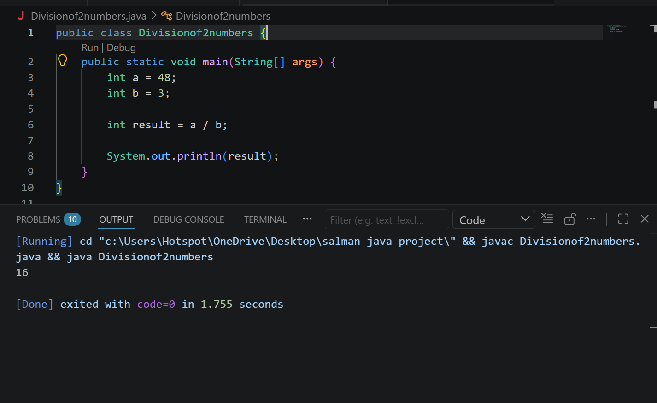

Explanation: In this problem i learned calculating the division of two integers using the / operator
And System.out.println(result) displayed the result

4. Write a java program to print the results of the following operations.(Arithmetic Operations)
Given:
- -5 + 8 * 6
- (55 + 9)%9
- 20 + -3*⅝
- 5 + 15 / 3*2 -8%3
Display Value ; 43
1
19
13
Solution:
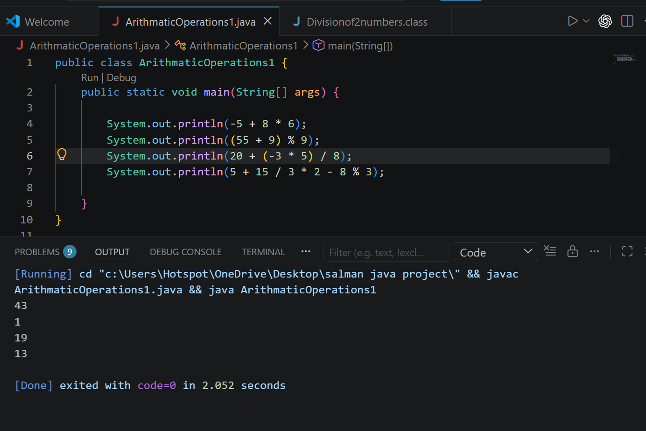
Explanation: Learned using arithmetic operation in java using arithmetical operators and got values of given operation accordingly 43, 1, 19 ,13 uses of +,-,*, / operators in java
5. Write a java program that takes two numbers as input and displays the product of two numbers.
Given data: First number :25
Second number: 5
Final answer 25 × 5 = 125
Solution :
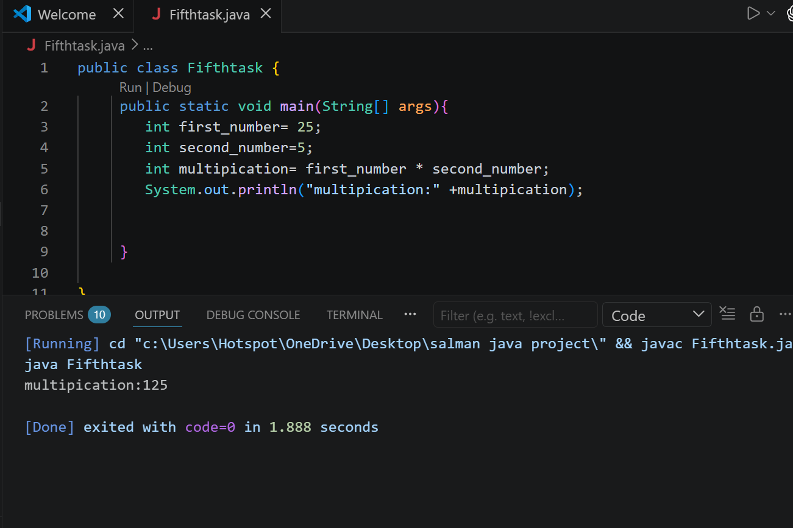
Explanation:
Declaration of numerical values and simple multiplication basic is learned by me here from this problem.

8.Write a Java program to display the following pattern. J a v v a
J a a v v a a
J J aaaaa V V aaaaa
JJ a a V a a
Solution:
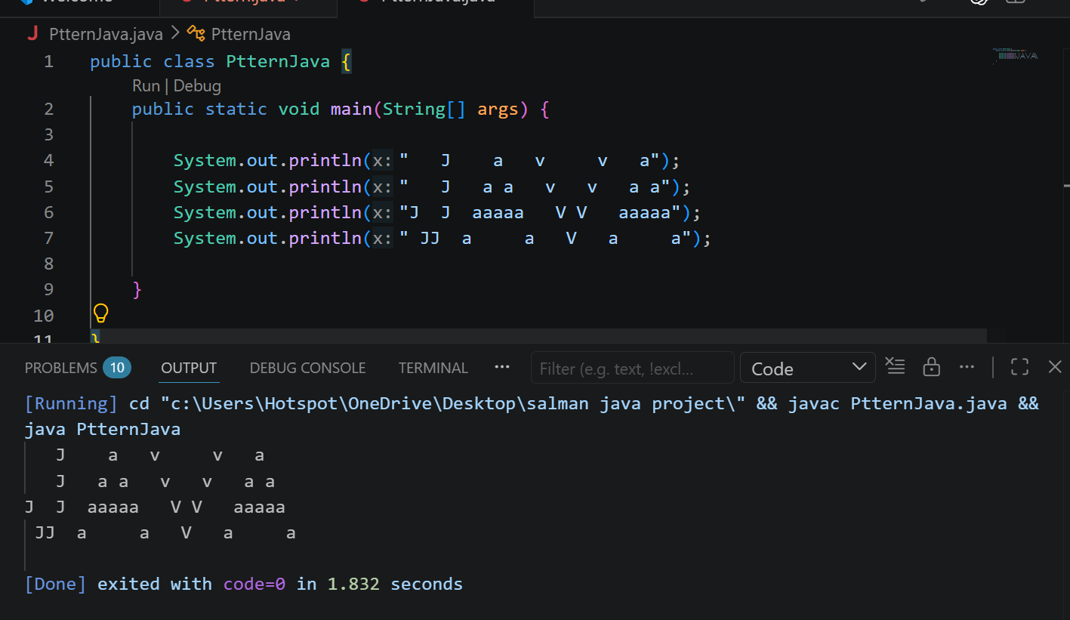
Explanation : Learned applying any kind of pattern or structure inside java code and also learned to make a shape using System.out.println() to display result according to given terms of question.

10. Write a java program to specify a compute formula.
4.0 * (1(1.0/3) + (1.0/5)(1.0/7) + (1.0/9)(1.0/11))
2.9760461760461765
Solution:
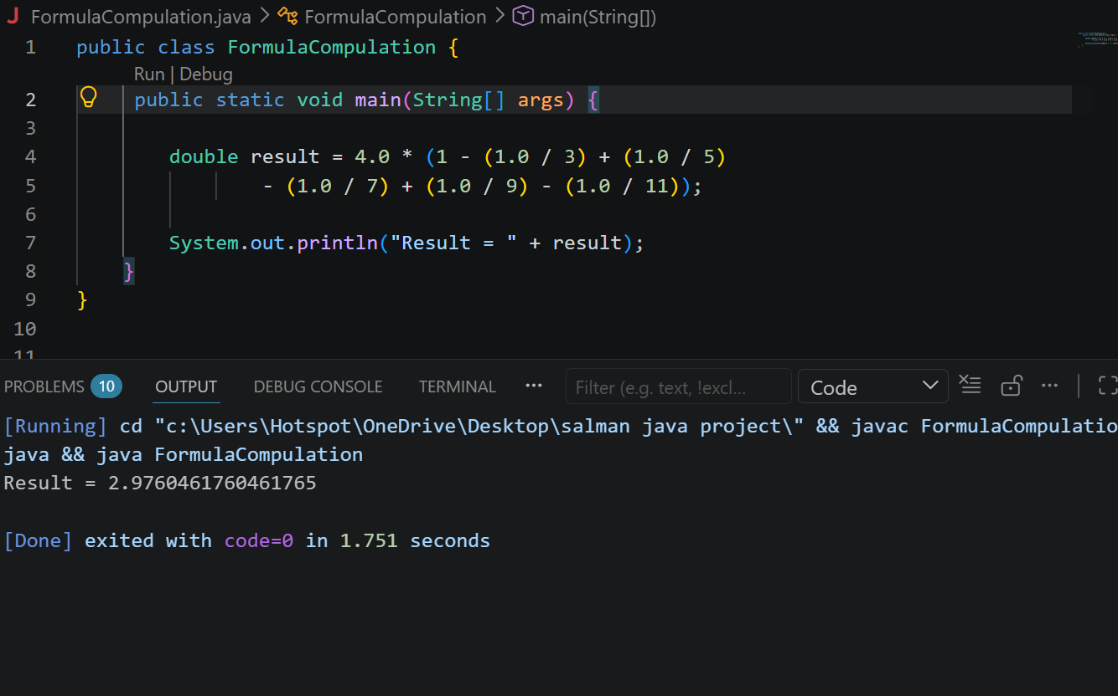
Explanation: Learned double decimal calculations in java program and how it actually works all along with different operators and how does it perform to display a mathematical equation or expression.

